**Shoot Phenotyping Protocol**

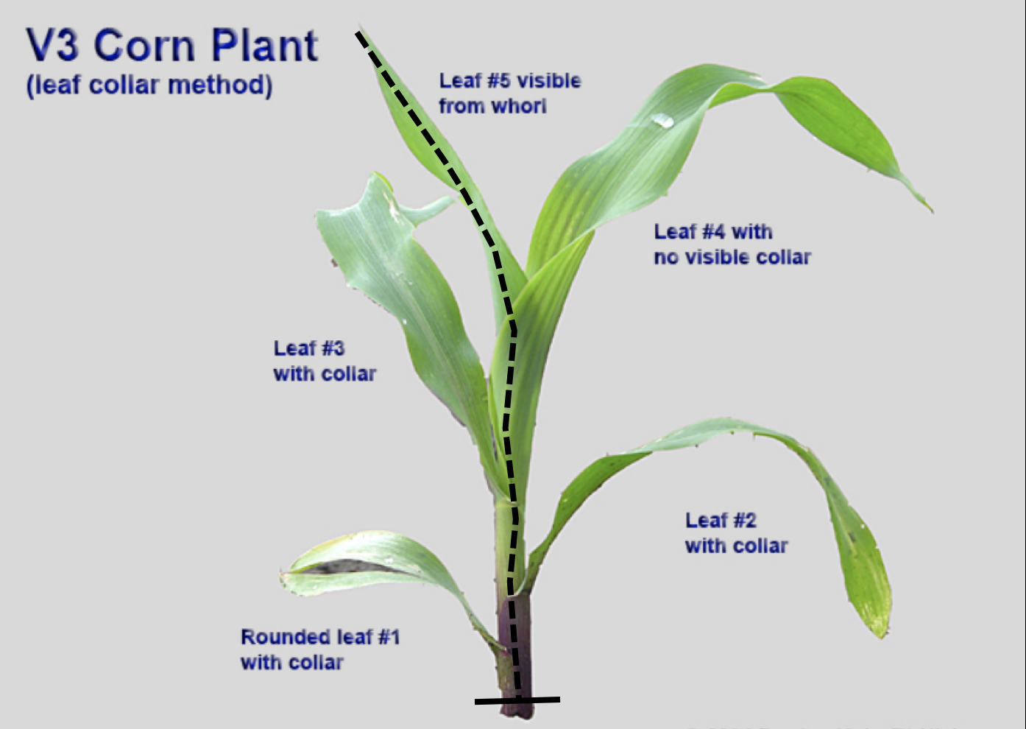

**Keeping track of your plants**

It is very important that the stem portion of each plant can be connected back to the root portion of the plant. Therefore, each plant should receive an identification number. When you separate the stem and shoot portion, remember to label carefully so that you know which root system belongs with which shoot system downstream.

**4th Leaf measurements**

You will need to observe your growing seedlings **everyday** to assess when leaf #4 blade tip is visible in the whorl. Once the tip of leaf #4 is above the leaf whorl, take a sharpie and make a mark at the base of leaf sheath #1, as close to the bottom of the shoot as possible but above the soil line. This is the “zero” mark for taking **daily** leaf length measurements. Starting from the first day leaf #4 is visible, measure from the sharpie mark at the shoot base to the tip of leaf #4, doing this at the same time each day. You will need to gently straighten the leaf so it is relatively linear. Take care to NOT pull off the leaf tip. If you do, record the length of the torn off tip and make sure to add that measurement to all subsequent length measurements. Each day, at the same time, measure the length of leaf #4 from the “zero” mark to the tip of the blade making sure to keep these data with the correct plant number. Leaf #4 will keep growing for about 2 weeks and the growth will gradually slow. When leaf #4 length has not changed for 3 consecutive days, it has reached its mature length and you can now proceed to termination of the plant, end-point leaf measurements, and root processing.

Telling when leaf #4 has stopped growing isn’t trivial. The best way to do this is to continuously graph (leaf length vs time) your data as you measure. You will see when the leaf plateau and will be able to stop the growth at the right time by watching the growth curve carefully.

**Termination of plant**

When leaf #4 has stopped growing for 3 days, cut the base of the shoot at the sharpie mark (as low on the 1st leaf as possible). Holding the base of the plant upwards with the leaves hanging downwards, carefully peel off each leaf at the sheath base, starting with the outermost leaf #1, and taking care to not damage it. For end-point measurements, dissect out the 4th, 3rd and 2nd (if still healthy) leaves (including the sheath) and number them accordingly. For each leaf (#’s 2 to 4), measure the sheath length (from base of sheath to auricle/ligule). Cut sheath from blade at the auricle/ligule. Measure the length of the leaf blade from the auricle/ligule to the tip of the blade. At 50% of the blade length, measure leaf blade width. If you cannot scan the leaf blade the same day, place the leaves into a plastic bag, blow in some air and seal the bag until the next day. For longer storage, keep the leaves in the fridge.

Wash the root system according to the [Root Phenotyping Protocol](https://docs.google.com/document/d/19UV63easgM4gtIno2HPfy1xuouM9tIhTm6ciPTWtpZo/edit#). Keep the root system cold until you are ready to wash them. Do not store longer than a couple of days. For longer storage, freeze the root system after washing.

**Setting up the leaves for scanning**

Cut the leaves into portions that would fit onto the scanner surface. Lay the leaves so that all portions of the blade are flat with the adaxial side against the scanner. Add a ruler and make sure to note the original plant number and leaf number for each scan.

**Scanning the leaves**

Open the Image Capture software.

Scanner parameters:

Kind: Black & White

Grays: 256 Grays

Resolution: 300 dpi

Use Custom Size: select the area you want to scan

Rotation Angle: 0

Auto Selection: Detect Enclosing Box

Scan To: Leaf scans

Name: Provide a name for each scan, following the format below

**inbred-plantNumber.jpg**

Format: JPEG

Image Correction: None

**ImageJ software to measure leaf area**

Install the open access ImageJ software to your computer: <https://imagej.nih.gov/ij/download.html>

1. Open the image in ImageJ
2. Set measurement scale  
    Using the “Straight” line tool, draw a line over a 50 mm section of the ruler  
    Go to Analyze > Set Scale

In Set Scale window enter 50 into the 'Known Distance' box

Change the 'Unit of length’ box to mm

Check 'Global'

1. Convert scanned image into black and white  
    Process > Binary > Make Binary
2. Calculate surface area

Analyze > Analyze Particles  
 Enter 50 as the minimum particle size

Check 'Show Outlines'

Check “Display Results’ and click 'OK'

Outline of the analyzed area will be drawn

**Saving data**

Save your data after the processing of each image into your [Shared Drive folder](https://drive.google.com/drive/folders/1lLY-l4rjIYfxg9flvHIrEljgUI5_7GnO?usp=sharing).

Click on the “Results” box

File > Save As

Save your data in csv format, making sure you label the appropriate data.

**Combine final data**

Once you have processed all of your images, combine the data into a single spreadsheet so that you can process your raw data in R.